Pipeline Diagram
Random Forest pipeline
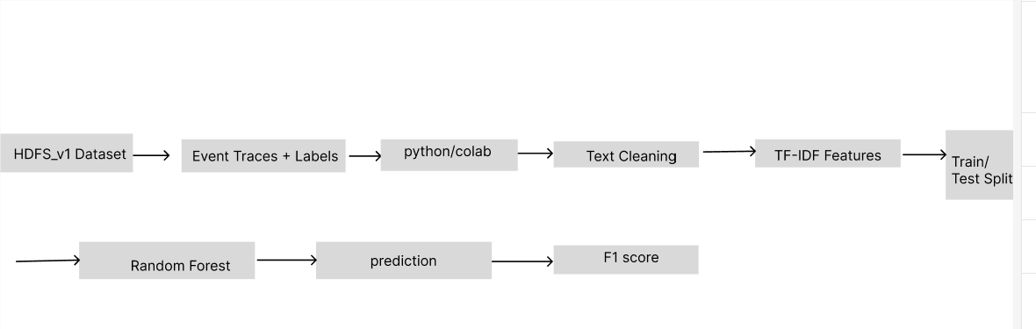
Figure: Random Forest Pipeline for HDFS Log Classification using TF-IDF Features
This pipeline illustrates the supervised learning approach using the Random Forest algorithm on the preprocessed HDFS dataset. Event traces and labels are used to generate TF-IDF features, which are then split into training and testing sets. The Random Forest model predicts whether a log sequence is normal or anomalous, and the performance is evaluated using the F1-score.
Isolation forest Pipeline
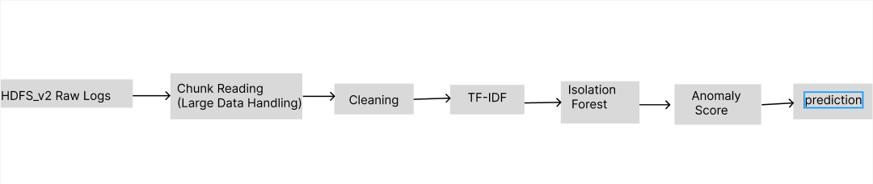
Figure: Isolation Forest Pipeline for Anomaly Detection on HDFS_v2 Logs
This pipeline represents the unsupervised anomaly detection approach using the Isolation Forest algorithm on large-scale HDFS_v2 logs. Due to the large size of the dataset, logs are processed using chunk-based reading to handle memory efficiently. After cleaning and transforming the data into TF-IDF features, the Isolation Forest model identifies anomalies by assigning anomaly scores, which are then used to classify logs as normal or anomalous.

LogBert Pipeline
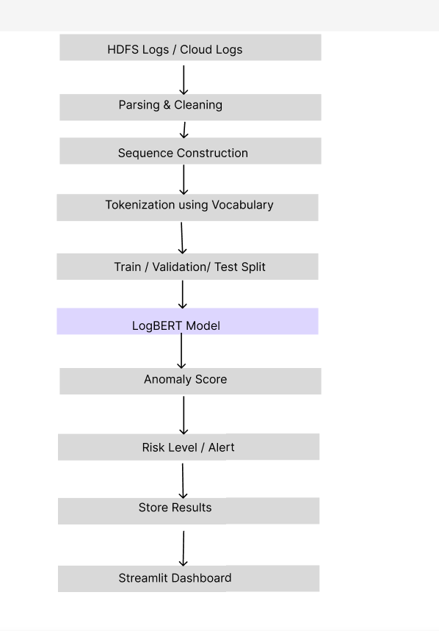
Figure: LogBERT Pipeline for Sequence-Based Anomaly Detection in HDFS Logs
This pipeline illustrates the LogBERT-based anomaly detection approach applied to HDFS and cloud-generated logs. The logs are first parsed and cleaned before being transformed into structured event sequences. These sequences are tokenized using a predefined vocabulary and split into training, validation, and test datasets. The LogBERT model then learns patterns in normal log sequences and generates anomaly scores for new data. Based on these scores, logs are classified into risk levels or alerts, and the results are stored and visualized through the Streamlit dashboard for monitoring and analysis.

Full Pipeline in AWS
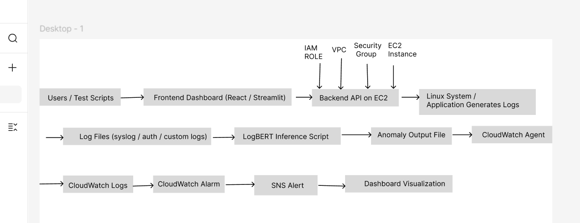
Figure : Full AWS-Based Deployment Pipeline for Log Monitoring and Anomaly Detection
This pipeline shows the deployment workflow of the anomaly detection system in an AWS environment. Users interact with the frontend dashboard, which communicates with the backend API hosted on EC2. Logs generated from the Linux system and applications are processed by the LogBERT inference script, which produces anomaly outputs. These outputs are collected through the CloudWatch Agent and sent to CloudWatch Logs for monitoring. CloudWatch Alarm and SNS are used to generate alerts, while the final results are displayed in the dashboard visualization layer.

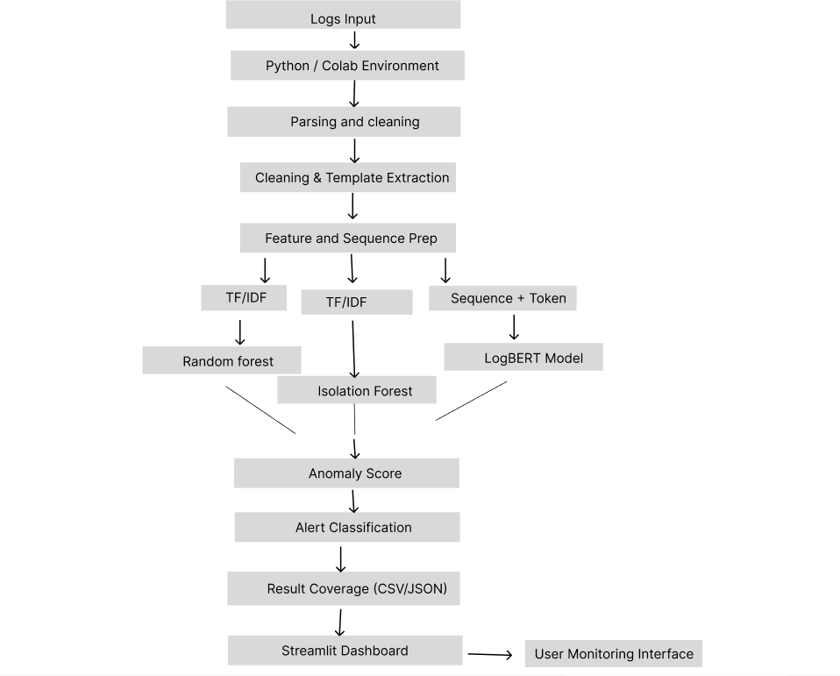

Fig 1: Figure 1: Detailed Dataflow Diagram of Log Processing and Anomaly Detection using Python/Colab Environment
This diagram illustrates the step-by-step flow of log data through the system. Raw logs from multiple sources are processed using Python/Colab, where parsing, cleaning, feature extraction (TF-IDF), and sequence construction are performed. The processed data is then passed through machine learning models such as Random Forest, Isolation Forest, and the LogBERT model to generate anomaly scores. Finally, the results are classified and visualized in the Streamlit dashboard.

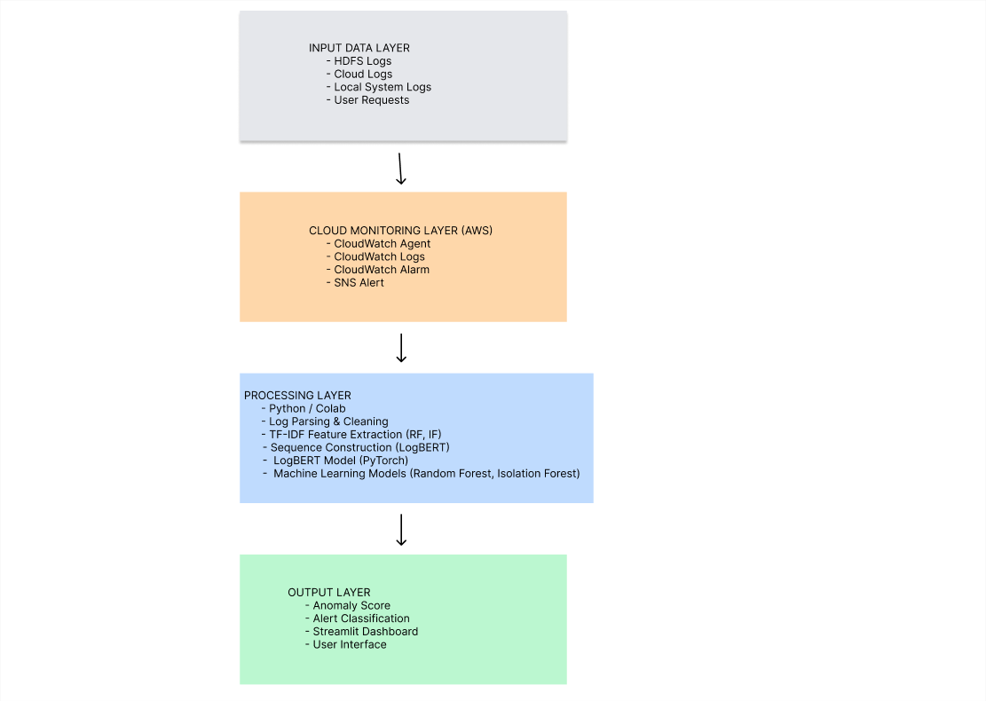
Fig 2: Figure 3: System Architectural Layout of the Proposed Cybersecurity Anomaly Detection System
This diagram presents the overall architecture of the system, divided into four main layers: input, cloud monitoring, processing, and output. The input layer collects logs from various sources, while the monitoring layer uses AWS services such as CloudWatch and SNS for tracking and alerting. The processing layer performs log analysis using Python, LogBERT, and machine learning models. The output layer displays anomaly results and alerts through a Streamlit dashboard.
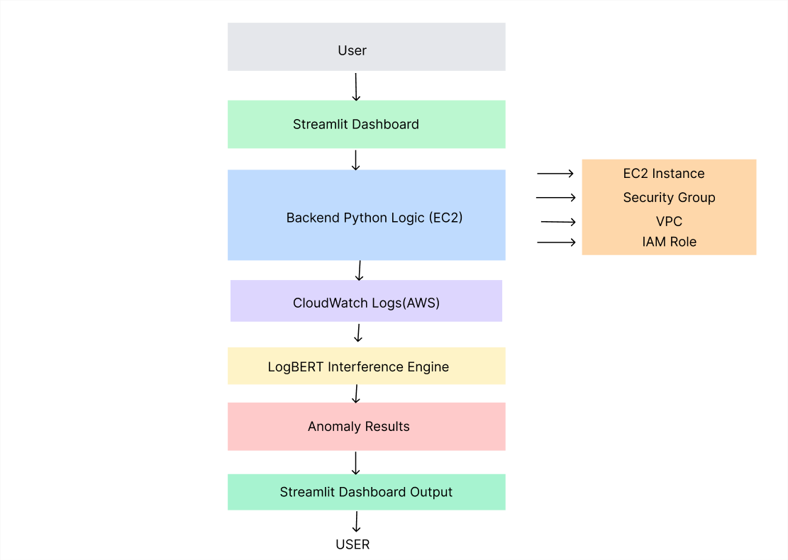
Fig 4: Figure 4: Network Model Showing Interaction Between User Interface, Backend System, and AWS Components
This diagram illustrates the network-level interaction between system components. Users access the Streamlit dashboard through a browser, which communicates with the backend Python logic hosted on an EC2 instance. The backend interacts with AWS CloudWatch for log retrieval and monitoring. The LogBERT model processes the logs and generates anomaly results, which are then sent back to the dashboard for visualization and user interpretation.
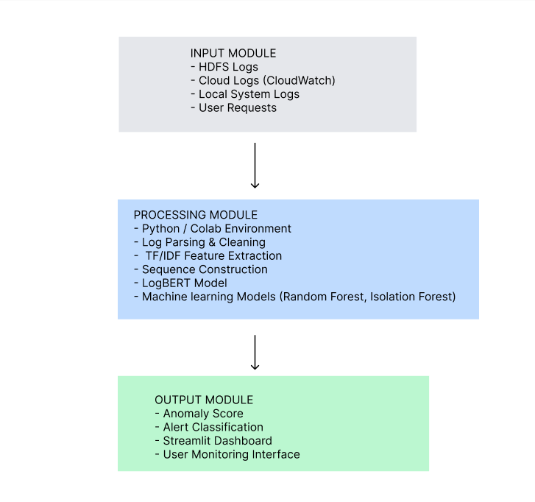
Fig 5: Figure 5: High-Level System Model of the Cybersecurity Anomaly Detection Framework
This diagram provides a simplified view of the system, divided into three main modules: input, processing, and output. The input module collects logs and user requests, the processing module performs data preprocessing and anomaly detection using LogBERT and machine learning models, and the output module presents the results through anomaly scores, alert classification, and a user-friendly dashboard interface.
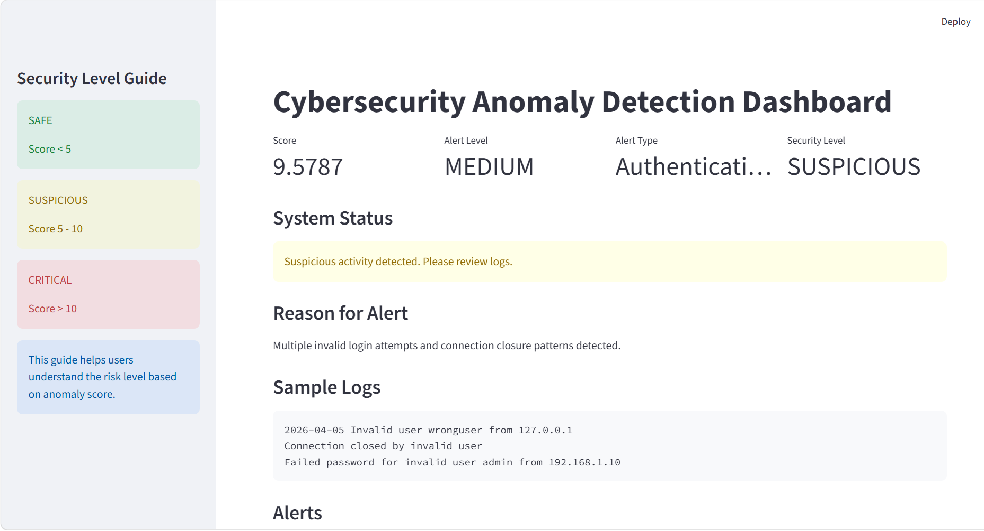
Figure 6: Streamlit-Based Cybersecurity Anomaly Detection Dashboard
The Streamlit dashboard provides a user-friendly interface to visualize anomaly detection results generated by the system. It displays key metrics such as anomaly score, alert level, alert type, and security level to help users quickly understand the system status. The dashboard also presents sample log activities and detected alerts, highlighting suspicious behaviour such as multiple invalid login attempts.
A security level guide is included in the sidebar to assist users in interpreting anomaly scores by categorizing them into safe, suspicious, and critical levels. This improves usability by allowing even non-technical users to understand the severity of potential threats. Overall, the dashboard acts as the final output layer, enabling real-time monitoring and decision-making.

Comparison of Random Forest, Isolation Forest, and LogBERT for HDFS Log Anomaly Detection
Model process and dataset used
1. TF-IDF + Random Forest
For the Random Forest model, the preprocessed HDFS_v1 dataset was used. This dataset already had a more structured format, which made it easier to work with compared to raw logs. In particular, the data already contained block-level event traces along with anomaly labels. Because of this, each block could be treated as one training sample with a known class, either normal or anomalous.
The process for this model was fairly simple. First, the event traces were converted into text form so that each block was represented as a sequence of event tokens. After that, TF-IDF was applied. This step transformed the text into numerical vectors by giving importance to tokens based on how often they appeared in one sample compared to the full dataset. Once these TF-IDF features were created, a Random Forest classifier was trained using the provided labels.
This model was mainly used as a supervised benchmark. It was useful because it was easy to train, quick to test, and gave clear evaluation metrics such as precision, recall, and F1-score. At the same time, it also had an obvious limitation. Since TF-IDF only captures token importance, the model mostly learns which events appear often or rarely. It does not properly understand the actual order of events inside a session. For log anomaly detection, this is important because many anomalies are caused not only by unusual events, but also by unusual event sequences.
So overall, Random Forest was a good traditional baseline, but it remained limited by the way the input data was represented.
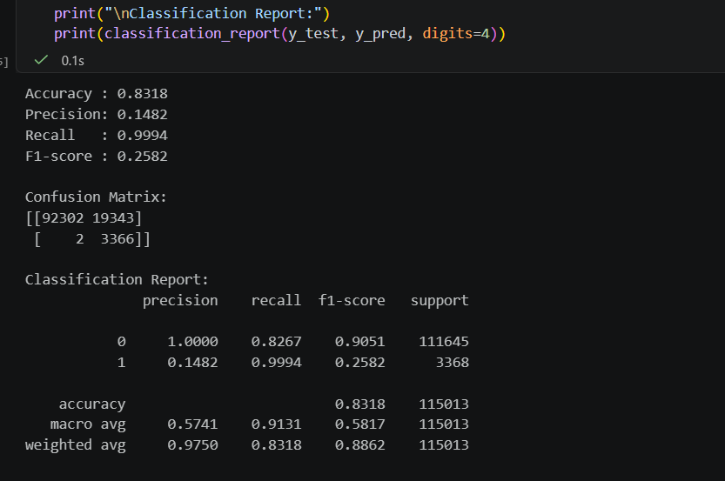

2. TF-IDF + Isolation Forest
For Isolation Forest, the HDFS_v2 dataset was used. Unlike HDFS_v1, this dataset was much larger and much closer to raw log data. It contained massive amounts of merged HDFS log messages, so working with it required much more care during preprocessing and feature extraction.
The process started with the HDFS_v2 log file being read in a memory-safe way, using chunk-based reading instead of trying to load the full file at once. Each log entry was cleaned by normalising text, removing unnecessary symbols, and simplifying values like numbers and IP addresses where needed. The cleaned logs were then converted into TF-IDF vectors, just like in the Random Forest approach. After that, Isolation Forest was trained on these vectors.
The key difference is that Isolation Forest is an unsupervised anomaly detection model. It does not learn from labels in the same way Random Forest does. Instead, it tries to identify which log samples are isolated or unusual compared to the rest of the data. This makes it more suitable for anomaly detection experiments on large-scale raw logs.
This is why Isolation Forest is methodologically closer to LogBERT. Both approaches are more naturally used for anomaly detection rather than for standard supervised classification. Even so, Isolation Forest still depends on TF-IDF features. That means it only sees logs as points in a feature space. It can detect unusual text patterns, but it cannot truly learn the relationship between one log event and the next. In practice, that means it may flag rare-looking operational messages as anomalies even if they are not actually meaningful failures.
So, Isolation Forest was a stronger baseline than Random Forest for comparing with LogBERT, but it still did not fully capture the sequential nature of the HDFS logs.
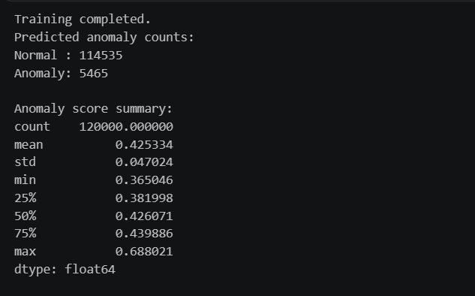

3. LogBERT
For LogBERT, the HDFS_v2 dataset was also used, but the processing pipeline was different because the model itself is different. Instead of treating logs as independent text samples, LogBERT required the logs to be converted into session-based event sequences. This was necessary because the model is designed to learn how events appear in sequence over time.
The HDFS_v2 logs were first grouped into sessions so that each session represented a meaningful block-level event flow. These sessions were then cleaned, tokenised, and encoded into a sequence format suitable for LogBERT. A vocabulary was built from the event tokens, the sequences were padded or trimmed to fit the model input size, and then the data was split into training and testing tensors. LogBERT was trained to learn the normal sequence behaviour of the log sessions, and during testing it produced anomaly scores based on how much a session differed from learned normal patterns.
This model is more advanced because it does not simply look at which events appear. It learns how events appear together, in what order, and in what context. That is a major advantage for log anomaly detection, because in real systems many abnormal cases are not caused by one rare token alone. Often the issue is that the sequence of events is unusual, incomplete, or happens in the wrong order.
The training results showed that the model learned useful patterns over time, with the training loss decreasing and the anomaly scores showing clear variation between less suspicious and more suspicious sessions. This gave stronger evidence that LogBERT was able to capture more meaningful behaviour from the HDFS_v2 logs than the TF-IDF-based models.
For that reason, LogBERT was treated as the main final model in the project.
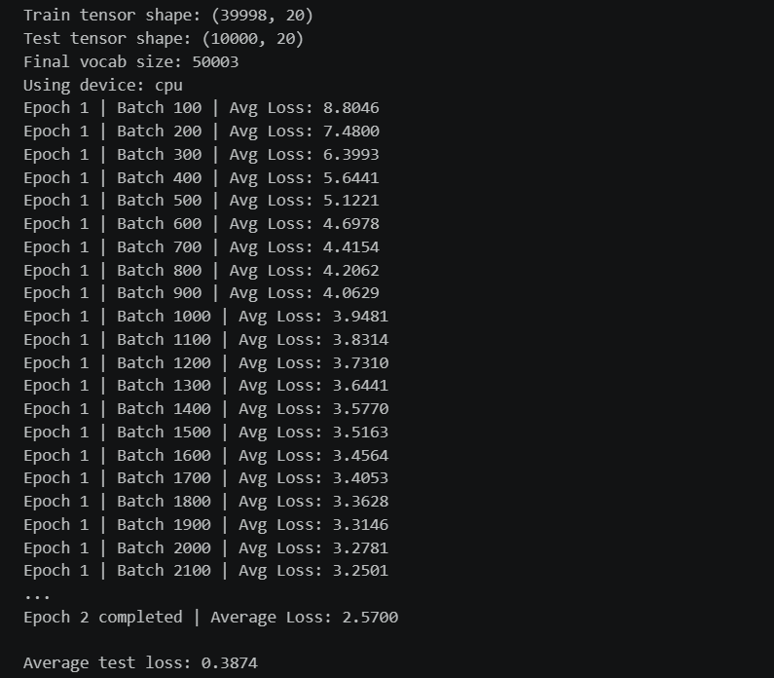
Problems faced while using HDFS_v2
Working with HDFS_v2 was one of the main challenges in the project because the dataset was extremely large. The file size alone made it impractical to use simple code that reads everything into memory at once. In early attempts, this could easily lead to the notebook or Python process becoming unresponsive. There was also a real risk of kernel crashes, memory overflow, or very long execution times, especially when trying to apply feature extraction or preprocessing directly on the full file.
A large raw log dataset like HDFS_v2 can create several practical issues:
- the notebook kernel may crash because RAM usage becomes too high
- the system may freeze or slow down heavily while building features
- full-file text processing can take too long to finish
- sparse feature generation can still become expensive if the text is not controlled carefully
- training anomaly detection models on large text representations can create heavy CPU and memory pressure
Some of these issues were directly experienced, while others were strong risks during implementation. To avoid these problems, the code had to be written in a low-memory and efficient way. Instead of loading the whole dataset into memory, the logs were processed in chunks. Cleaning steps were kept lightweight, only the needed columns were read, and the TF-IDF setup was controlled to avoid unnecessarily large feature spaces. This made the processing much more stable and reduced the chance of kernel crashes or memory-related interruptions.
For both Isolation Forest and LogBERT, the work was kept aligned around the same HDFS_v2 source dataset, but each model required a different preparation method. Isolation Forest needed efficient text cleaning and vectorisation, while LogBERT needed the logs to be turned into session sequences. Even though the input representation was different, both approaches were still built from the same HDFS_v2 log source, which keeps the comparison more consistent.
So, one important part of the project was not only model selection, but also designing a workflow that could handle a very large dataset without breaking the environment. This made memory efficiency and preprocessing design just as important as the models themselves.

Score summary
Model | Dataset used | Type | Main result
TF-IDF + Random Forest | HDFS_v1 preprocessed | Supervised | Default: Accuracy 0.8318, Precision 0.1482, Recall 0.9994, F1 0.2582
TF-IDF + Isolation Forest | HDFS_v2 logs | Unsupervised | Normal: 114,535, Anomaly: 5,465, mean anomaly score 0.4253, max 0.6880
LogBERT | HDFS_v2 session-based sequences | Sequence-aware deep model | Test loss 0.3874, mean anomaly score 0.3009, max anomaly score 15.5338

What the scores mean
Random Forest
Random Forest gave weak results at the default threshold because it marked too many normal cases as anomalies. That is why the precision started very low. After threshold tuning, the results improved a lot, and the model reached a strong F1-score. This shows that Random Forest can perform well, but it needs extra adjustment and still depends on a simpler bag-of-tokens style representation.
Isolation Forest
Isolation Forest successfully produced anomaly scores and identified unusual log entries from HDFS_v2. This showed that it could work as an anomaly detector on raw log data. However, many of the top anomalies appeared to be repetitive operational logs rather than clearly abnormal failures. This suggests that the model was reacting more to unusual text patterns than to meaningful log behaviour.
LogBERT
LogBERT showed better learning behaviour during training and produced a much wider range of anomaly scores. This wider score separation suggests that it was more effective at distinguishing normal sessions from suspicious ones. The training loss also decreased properly, which gave further support that the model was learning useful sequence patterns.

Why Isolation Forest is closer to LogBERT than Random Forest
Isolation Forest is closer to LogBERT because both are more naturally used for anomaly detection rather than normal supervised classification.
Random Forest mainly learns from labeled examples and predicts classes based on those labels. Isolation Forest, like LogBERT, is more focused on identifying unusual behaviour from the data itself. This makes it a more appropriate comparison baseline when the main goal is anomaly detection on large HDFS logs.
In simple terms:
- Random Forest learns to classify based on labels
- Isolation Forest learns to spot unusual patterns without depending on the same supervised setup
- LogBERT learns what normal event sequences look like and detects when those sequences become unusual
Because of this, Isolation Forest is the more logical baseline for comparison with LogBERT.

Why LogBERT is the best of all three
LogBERT is the strongest final choice because it matches the real nature of the problem much better.
Both Random Forest and Isolation Forest depend on TF-IDF features. That means they mainly focus on token presence, rarity, and general text patterns. They can be useful, but they do not really understand sequence order or context inside the logs.
LogBERT is better because it learns directly from the event sequence. It can capture how events usually follow one another and recognise when a sequence behaves differently from normal. This is exactly the kind of information that matters in log anomaly detection.
So the overall logic is:
- Random Forest is useful as a simple supervised benchmark
- Isolation Forest is a better anomaly-detection baseline because it is closer in setup to LogBERT
- LogBERT is the best overall model because it is sequence-aware, context-sensitive, and more suitable for real HDFS anomaly detection
Final Algorithm selection
Among the three models, LogBERT is the best overall choice for the project. Random Forest was useful for showing how a standard supervised model performs on structured HDFS data. Isolation Forest was a better comparison baseline because it is unsupervised and methodologically closer to LogBERT. However, both classical models remained limited by TF-IDF features and could not fully capture the sequence structure of the logs.
LogBERT was the strongest model because it was designed for sequence-based anomaly detection, showed stable learning, and produced more meaningful anomaly separation. For that reason, it is the most suitable final model for the HDFS log anomaly detection task.

